**BEFORE THE BOARD OF COUNTY COMMISSIONERS**

**Klickitat County, Washington**

IN THE MATIER OF } SETTING A PUBLIC HEARING TO } CONSIDER IMPOSING THE } OPTIONAL SALES TAX SECOND } HALF-CENT

13221

RESOLUTION# ----

WHEREAS, the Board of County Commissioners, meeting in regular session, and having before it the need to set a public hearing date to consider imposing an additional sales and use tax at the rate of .5%; and

WHEREAS, pursuant to RCW 82.14.030(2) the County may by resolution or ordinance impose an additional sales and use tax at the rate of .5%; and

WHEREAS, the County would receive 15% of the second half revenues from the city under RCW 82.14.030(2) as a revenue sharing provision; and

WHEREAS, these revenues are unrestricted and may be used for any lawful governmental purpose.; and

WHEREAS, the County would rescind the resolution allowing a .25% charge on real estate excise in lieu of"Second Half' sales tax per RCW 82.46.010(3); and

NOW, THEREFORE, BE IT RESOLVED, that a public hearing will be held on the 4th day of January 2022, beginning at the hour of 1:30 PM in the office of the Board of County Commissioners, and notice of said hearing shall be published in the official newspaper of Klickitat County and that, at said hearing, any interested taxpayer may appear and be heard for or against the proposal.

DATED this 14th day of December 2021.

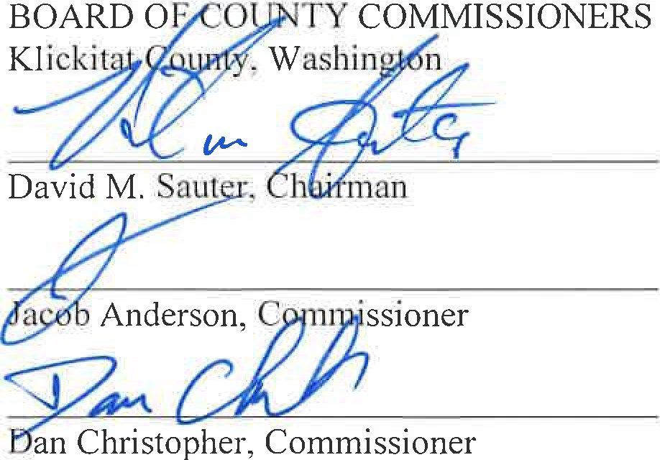

ATTEST:

kitat,

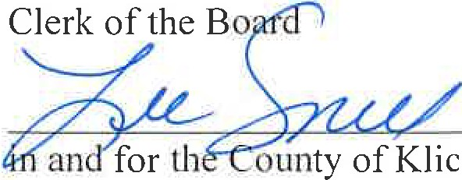

State of Washington